12 Week Program guide – Club Set Up

Revision 1.1 January 2021

SportLoMo Ltd.

Contents may not be reproduced without the express approval of

SportLoMo Ltd.,
Barcastle Business Park,
Castlebar,
Co Mayo,
Ireland.

Canada: +12898579559
www.sportlomo.com
info@sportlomo.com

Step 1:
- Log into your Sportlomo account.

Step 2:
There is only 2 main differences in setting up this event type versus other event set ups.

- On your home page – Select events

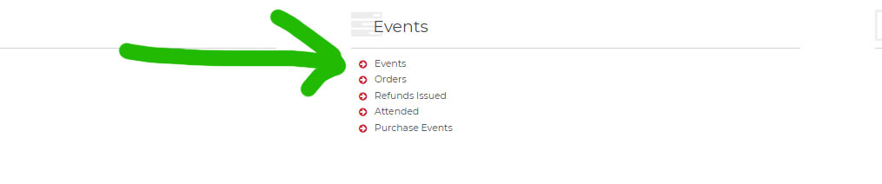

- To create this 12 week membership select The ADD button.

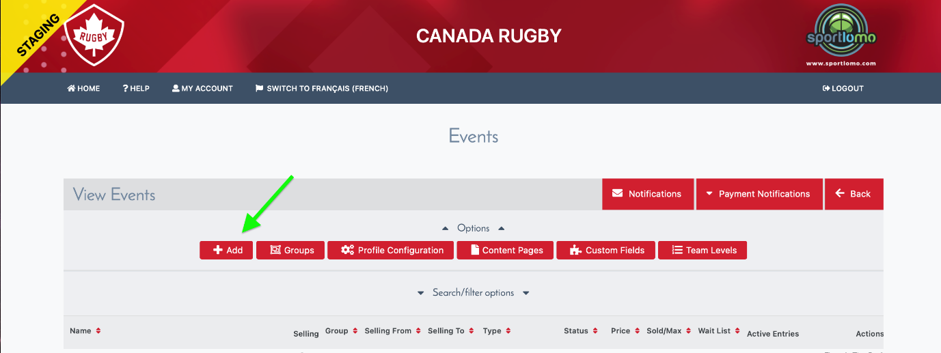

Step 3:
You will see the ability to edit 5 sections, however only Details / Pricing and Outcomes tabs are applicable to sell this program.

Details / Pricing / Prerequisite / Outcomes / Instalments Set up

Details Tab
(On the first page the main fields to set up a program event are in bold)

- Event Name - will be what member sees as main item line

- Description: - Additional details of the program, times, day of week etc

- Additional Info: Only to be used if you are selling in an external website – not needed here for programs
Event Group: You can categorise event groups, eg Referee events, Coach events etc

- Event Type: Program must be selected

- Requires Membership:
  - None - you are allowing a non member to purchase this plan
  - Any Membership – Any active member can purchase
  - Specific Categories – Eg only a U12 member can purchase
  - Specific Parent Categories – Eg Any underage member can purchase

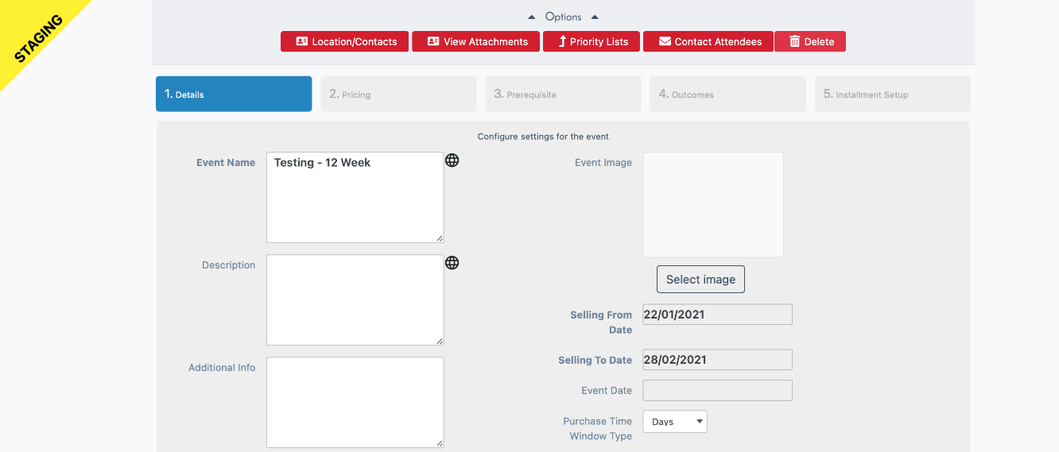
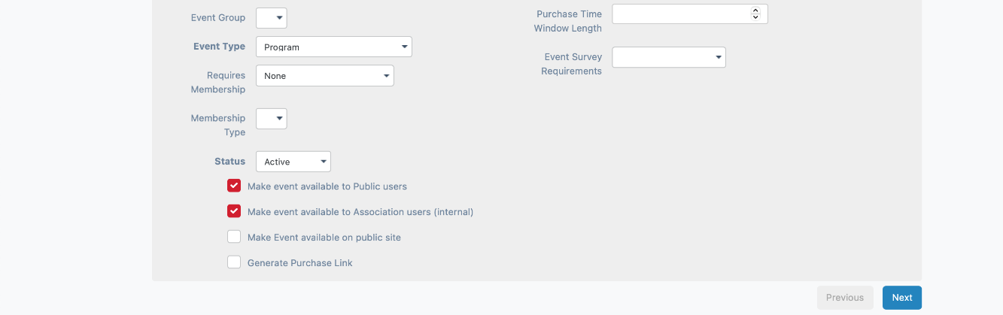
- Membership Type – Only member types that have allow in events ticked in their categories will appear here – not needed for selling Programs

- Status – Makes it easier to find grouped events in search filter – if you want to sell this event it will need to be in active mode. Make the event status active when you want to start selling this program to your membership.

- Tick Boxes:
  - Make event available to Public users – Non members can purchase.
  - Make event available to Association users (Internal) - Existing members can purchase
  - Make event available on public site - If the clubs used Sportlomo for the public display of these events on website – you can turn event on or not for public.
  - Generate Purchase Link - if the club wants to display the event on a Sportlomo event calendar but allow an external supplier to sell it, eg Ticketmaster

- Event Image – If the club would like to add a event image

- Selling From Date & Selling To Date - this is dates that your 12 week program is available to purchase not the length of the membership

- Event Date – Date when program is starting

- Purchase time window type & Purchase Time Window Length - How long you allow it to sit in a purchasers shopping basket without him buying it

- Event Survey Requirements - Not needed for program sales

Step 4:

Details / Pricing / Prerequisite / Outcomes / Instalments Set up

Pricing Tab

- Price = Cost of Program – note if there is a charge on the event it will be charged every time a user purchases it regardless of what you have set as the charge type in the member category when creating this membership – leave as 0 if needed and the system will only charge the cost of the program created on the category

- Handling Fee – Is there an extra charge on top of the cost, select 0 if there isnt (mainly used for post and packaging etc)

- Max Quantity: How many programs are for sale, enter a maximum value….eg if unlimited put in a million

- Per user: How many can one user buy, enter a maximum value that one user can purchase

- Wait List: Are you offering a wait list if program is sold out? If you don’t want a wait list enter 0

- Wait list Quantity: Enter how many people are you going to allow on the wait list if you intend to use a wait list

- Configure Taxes: Do taxes apply on this program, leave blank if not required

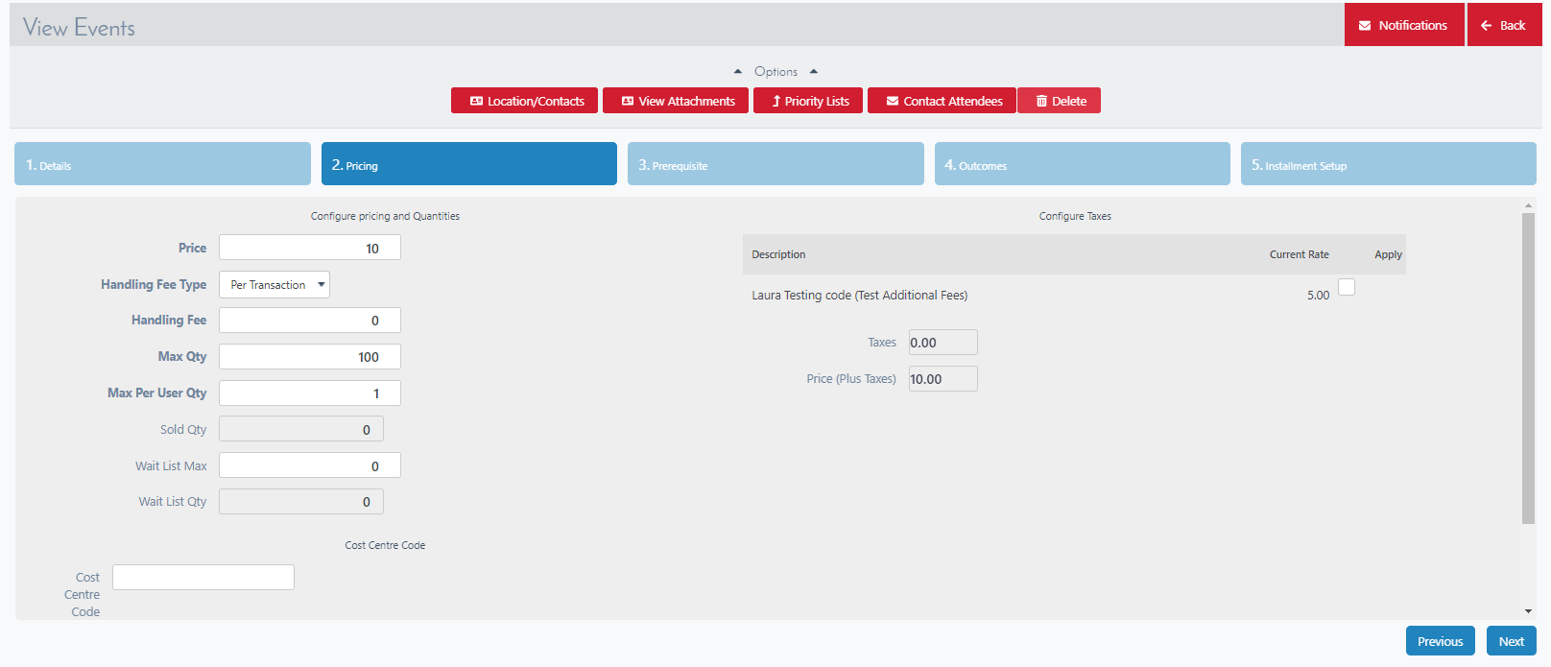

Step 5:

Details / Pricing / Prerequisite / Outcomes / Instalments Set up

Skip Prerequisite Tab – Not needed for program events.

Step 6:

Details / Pricing / Prerequisite / Outcomes / Instalments Set up

Outcome Tab

- Membership Type: Only membership categories that have added a program option from your NSO or PSO will appear here. Select the correct program from the drop down selection.

- Start Date: The start date of the program.

- End Date: The end date of the program.

- You will only be allowed to work within the time frame that your NSO/PSO has allowed on the program

Select next at bottom of screen
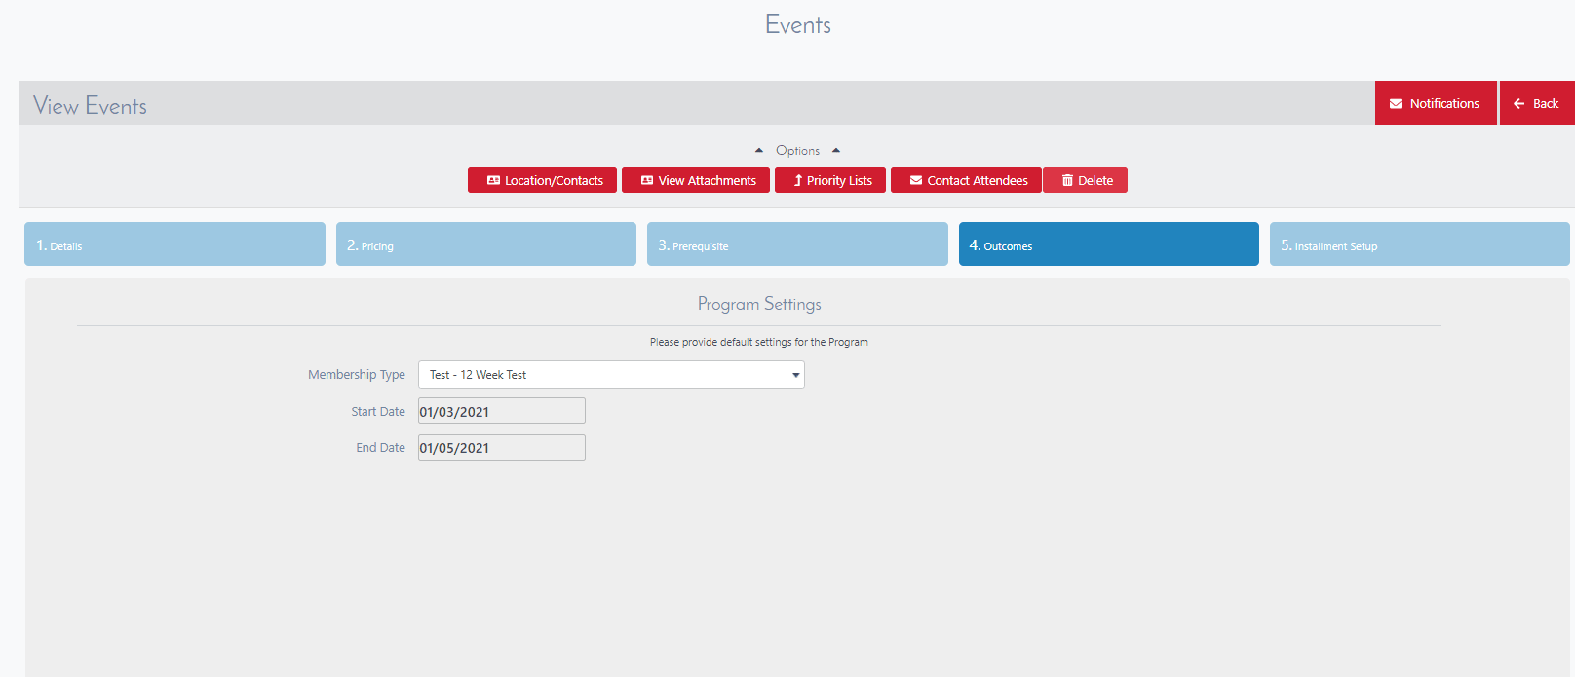

Step 6:

Details / Pricing / Prerequisite / Outcomes / Instalments Set up

Skip Instalments Set up Tab – As we do not offer Intsallments on this program

Select FINISH at bottom of screen

Event form

The event form is managed from the “membership type” page the same as a normal membership registration form is managed. The program category needs a membership type (registration form) associated to the category. The program category will usually be already setup from the level above. This tutorial video will help managing the membership form.

Manage membership types

