Sending notifications from the Sportlomo Admin

Revision 1.1 June 2020

SportLoMo Ltd.

Contents may not be reproduced without the express approval of

SportLoMo Ltd.,
Barcastle Business Park,
Castlebar,
Co Mayo,
Ireland.

+353 94 9026663
www.sportlomo.com
info@sportlomo.com

Your league or club admin has the ability to send notifications from the system to their membership

To begin

Step 1

Log into your admin account
Go to the Communications section and select Notifications and search for the player you wish to upgrade and select his full member profile by clicking on the information icon in the Action column to the right of his name

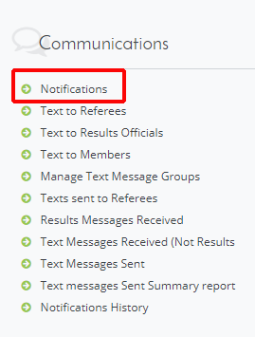

Step 2

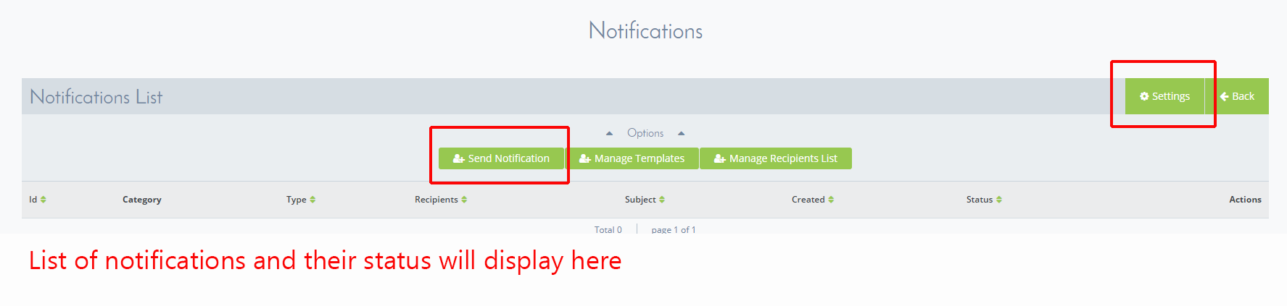

You will see then see the notification system – the first one we would recommend selecting is the SETTINGS button, accessing this will allow you to change the header that will display on the recipient’s email when he reads it. Upload your new banner and click save

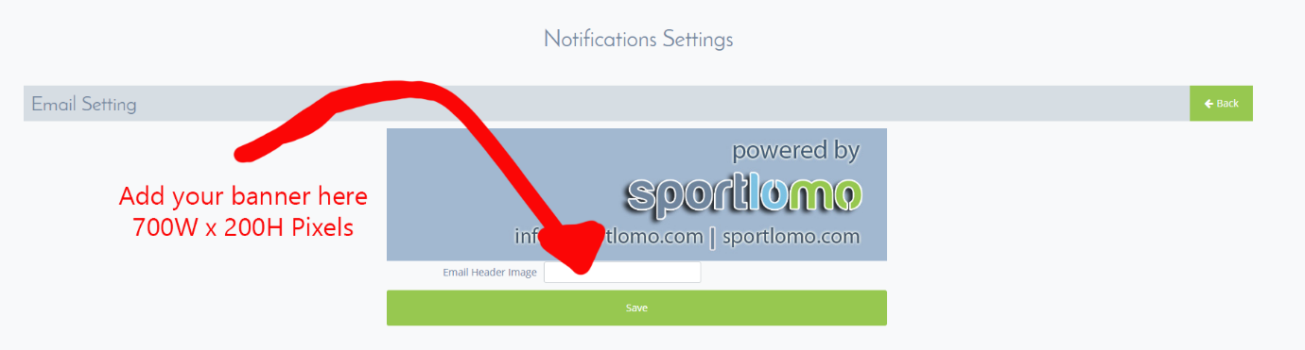

Step 3

Go back to the notifications page and click on the SEND NOTIFICATION button

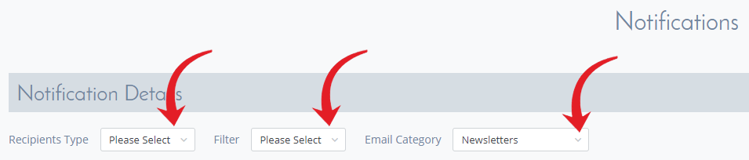

Recipients type = Select from members or officials
Filter = Search Members
Email category = Newsletter or member notifications

Step 4

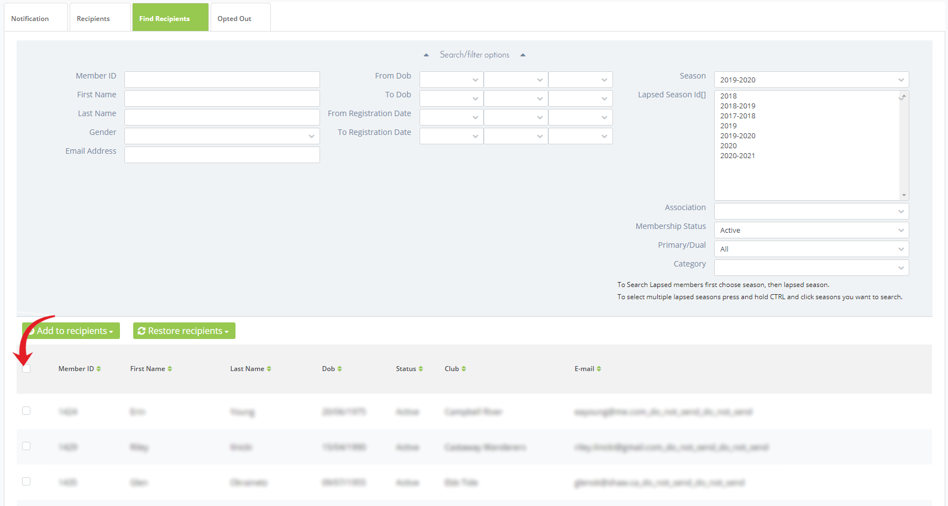

Select search members will produce all the members in the system for the active season, you can select many search filters from the dashboard such as member ID, Name, email, registration dates, dobs, member category and member seasons. Leagues will have the extra options of selecting a club within their membership.

Either select the tick box on the left of each individual member record or select the top tick box and it will select all members from the search filter

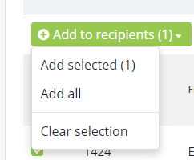

Select Add to recipients and either add the members that you ticked, add all or clear the selection and start again. This will remove these members from the Find recipients list and add them to the Add recipients list in the adjoining recipient tag. Once you are happy with your recipient list, click on the Notification tab to go back to your email.

Step 5

Enter your subject line and type up your email, to personalise your email, insert the two member variables and it will add the first name and surname of the member on every email. There is a small bit of formatting allowed through the Froala editor. Please note member attachment is not available at this time.

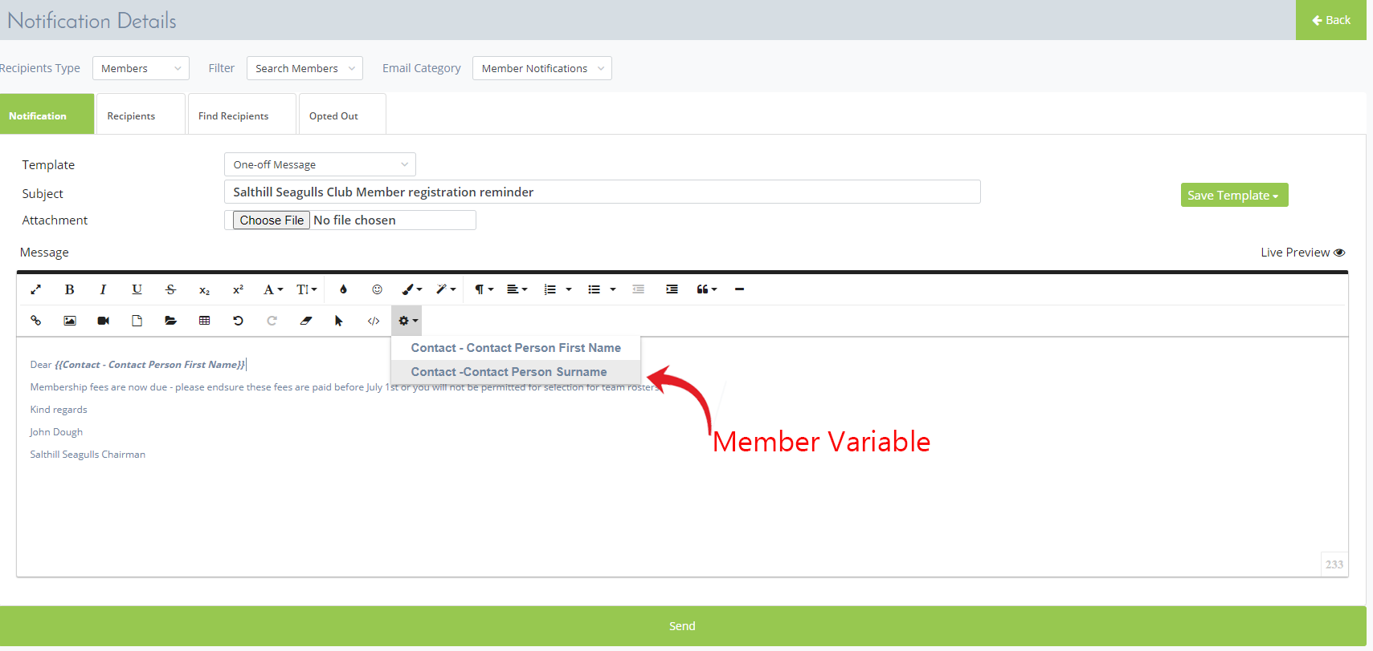

If this email notification is an email that you may use on a regular basis, you have the option of saving it as a template by selecting the green Save Template button on the top right of the email.

In future emails you can access the saved email templates by changing the One off Message drop down form to select from one of your saved messages

The Opted out tab will show you a list of users that opted out of receiving the newsletters

When you are ready to send this email click the large green Send button on the bottom underneath the email dialogue section

Create Recipient List

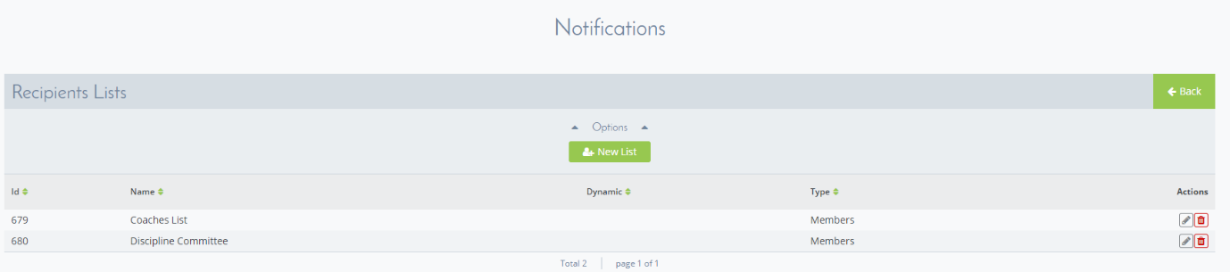

If you wish you can also create a new recipient list that you can use quickly if needed, select add new list, select your members and save the list.

Please note to access both saved email templates and recipient lists you will need to have your members on display first – so it will be necessary to have the Select recipients and Filter Search members active before they will display

